Test Bank - Chapter 5
The questions in the test bank cover the concepts from the lessons in Chapter 5. Select questions from any of the categories that match the content you covered with students. The types of questions include multiple choice, true/false, fill-in-the-blank, and short answer.

Multiple Choice

- A water molecule has the chemical formula H₂O. This means that the water molecule is made up of
  - Two hydrogen atoms and one oxygen atom
  - Two oxygen atoms and one hydrogen atom
  - Two hydrogen atoms and two oxygen atoms
  - Two molecules of water

- The atoms in a water molecule are held together by covalent bonds. This means that the bonded atoms
  - Lose protons
  - Lose electrons
  - Share electrons
  - Switch neutrons

- The water molecule is a polar molecule. A water molecule is polar because
  - The electrons are shared equally
  - Oxygen has a stronger attraction for electrons than hydrogen
  - It is very cold
  - Hydrogen atoms have a stronger attraction for electrons than oxygen

- The water molecule is
  - Slightly negative near the hydrogen atoms and slightly positive near the oxygen atom
  - Slightly positive in all areas of the molecule
  - Slightly negative near the oxygen atom and slightly positive near the hydrogen atoms
  - The same charge in all areas of the molecule

- Water molecules are attracted to each other because
  - They are all positively charged
  - Each water molecule has the same number of protons as electrons
  - The positive area of one water molecule is attracted to the negative area of another
  - All water molecules are neutral

- If liquid A is more polar than liquid B, you might expect
  - Liquid A to evaporate faster than liquid B
  - Liquid A to evaporate more slowly than liquid B
  - Liquid A and liquid B to evaporate at the same rate
  - Liquid B to be colored

- A paper clip can stay on the surface of water because of water’s strong surface tension. Water’s surface tension is mostly a result of
  - Water’s temperature
  - The motion of water molecules
  - The attraction of water molecules
  - The impurities in the water

- Sodium chloride is made up of sodium ions and chloride ions which bond together in a salt crystal because
  - They have the same charge
  - They are the same size
  - One is positive and one is negative, so they attract
  - They both have protons and electrons

- Water can dissolve sodium chloride because
  - The polar areas of water molecules attract the oppositely charged ions of sodium chloride
  - The shape of the water molecules pushes the sodium and chloride ions apart
  - The oxygen in the water molecules reacts with the sodium and chloride ions
  - Water molecules and sodium chloride are covalently bonded

- Water cannot dissolve all substances that are made from ionic bonds. This is probably because
  - Some water molecules are not as strong as others
  - Water needs to be stirred to dissolve all ionic substances
  - Some ionic bonds are too strong for the attractions of water molecules to pull them apart
  - Water needs to be heated to dissolve all ionic substances

- The chemical formula for sucrose (sugar) is C₆H₁₂O₆. In some parts of the sucrose molecule, oxygen is covalently bonded to hydrogen. This makes the sucrose molecule
  - Bonded like salt
  - Smaller than a water molecule
  - A polar molecule
  - Act like a liquid

- Sucrose dissolves well in water because
  - Water is usually warm
  - Sucrose is used to make sweet beverages
  - Polar water molecules attract the opposite polar areas of the sucrose molecules
  - Polar water molecules attract the carbon atoms in the sucrose molecules

- When sucrose dissolves in water
  - The sucrose molecules break apart into individual atoms
  - The water molecules covalently bond to the sucrose molecules
  - The water molecules cause the sucrose molecules to separate from one another
  - Each sucrose molecule breaks in half

- Alcohol molecules are not as polar as water molecules. If you mixed sucrose in alcohol, you might expect the sucrose
  - To dissolve better in alcohol than in water
  - To dissolve in alcohol not as well as in water
  - To dissolve equally well in alcohol and in water
  - To increase in size

- Dissolving often involves a solid dissolved in a liquid. In this type of dissolving
  - The solid is the solvent
  - The liquid is the solute
  - The solid is both the solvent and the solute
  - The solid is the solute and the liquid is the solvent

- The solubility of a substance
  - Is the solvent minus the solute
  - Is the mass of the substance plus the mass of water it dissolves in
  - Has nothing to do with the temperature of the water
  - Is the mass of a substance that will dissolve in a certain volume of water at a certain temperature

- Sugar is more soluble at higher temperatures. This is mainly because at higher temperatures
  - Sugar and water molecules move slower, and their interactions make the sugar molecules stay together longer
  - Sugar and water molecules move faster, and their interactions make the sugar molecules separate from one another
  - Water molecules spread out more, making more room for the sugar molecules
  - Water molecules actually come apart into separate atoms and react with the sugar

- Water is not a good dissolver of oil mainly because
  - Oil is also a liquid
  - Oil is thicker than water
  - Oil molecules are non-polar
  - Oil is colder than water

- Carbon dioxide gas dissolves pretty well in water because
  - The molecules of a gas are far apart compared to the molecules of a liquid
  - The bond between the carbon and oxygen in the carbon dioxide is polar
  - Water can dissolve anything with carbon
  - Water molecules are non-polar

- The amount of gas that can dissolve in water
  - Increases as the temperature of the water increases
  - Increases as the temperature of the water decreases
  - Does not change when the temperature of the water changes
  - Does not depend on the type of gas

- When certain substances dissolve, the solution gets warmer. This type of dissolving process is exothermic. In exothermic dissolving
  - More energy is released when water molecules bond to the solute than is used to pull the solute apart.
  - More energy is used to pull the solute apart than is released when water molecules bond to the solute.
  - A gas is always produced
  - The temperature does not change

- When certain substances dissolve, the solution gets colder. This type of dissolving process is endothermic. In endothermic dissolving
  - More energy is released when water molecules bond to the solute than is used to pull the solute apart.
  - More energy is used to pull the solute apart than is released when water molecules bond to the solute.
  - Water molecules break apart into atoms
  - The temperature does not change

Chapter 5
Multiple Choice Answers

- a  - c  - b  - c  - c  - b  - c  - c  - a  - c  - c | - c  - c  - b  - d  - d  - b  - c  - b  - b  - a  - b

True/False and Fill-in-the-blank

True or False?
Water is a polar molecule. True

The electrons in the covalent bond between hydrogen and oxygen in a water molecule are shared, but they are not shared _______. equally

True or False?
Water has areas of slight positive and negative charge. True

The attraction of molecules at the surface of a liquid is called
surface tension.

The of water enables it to dissolve salt. polarity

The substance being dissolved is called the ______ , and the substance doing the dissolving is called the __ . solute, solvent

True or False?
Sucrose is a polar molecule. True

True or False?
A non-polar liquid, like mineral oil, can easily dissolve sugar. False

True or False?
Each substance has its own characteristic solubility. True
Adding increases molecular motion. Energy or heat
True or False?
A substance dissolves to the same extent at any temperature. False

True or False?
Polar liquids, like water, dissolve other liquids which are polar or somewhat polar. True
Gas stays dissolved more effectively in ____ water. cold
If the process of dissolving a solid in a liquid is exothermic, then the temperature
. increases

True or False?
In a sample of water, the areas of slight positive charge of one water molecule are attracted to areas of slight negative charge of another water molecule. True

Short Answer

Explain, on the molecular level why water molecules have an attraction for each other. Water molecules have an attraction for each other because they are polar molecules. They have a slight negative charge near the oxygen atom and a slight positive charge near the hydrogen atoms. The positive part of one molecule attracts the negative part of another.

What does it mean to say that something is a “polar molecule”?
A polar molecule is a molecule that has a slight positive charge in one part of the molecule and a slight negative charge in another. This happens in certain molecules, like water, because the sharing of electrons in their covalent bonds is not equal.

What is surface tension and why does water have a strong surface tension?
Surface tension is how strong the surface of a liquid is. Water has a strong surface tension because water molecules are very attracted to each other. The ones at the surface are attracted down and in and form a strong surface.

A water molecule (H₂O) is polar. This means that it has a slight negative charge near the oxygen atom and a slight positive charge near the hydrogen atoms. Using what you know about covalent bonding in the water molecule, explain why a water molecule is polar.
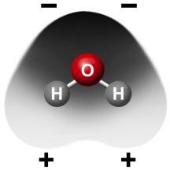

In the covalent bond between oxygen and hydrogen in a water molecule, electrons are shared between the oxygen atom and the hydrogen atom. But the electrons are not shared equally. They are attracted a bit more to the oxygen atom, so the oxygen part of the molecule is slightly negative. Since the electrons are pulled away from the hydrogen atoms a bit more, the area near the hydrogen atoms is slightly positive.

You put a drop of water and a drop of alcohol on a paper towel and saw that the alcohol evaporated faster than the water. Alcohol molecules are not as polar as water molecules. Use the difference in polarity between water and alcohol molecules to explain why alcohol evaporates faster than water.
Since water is more polar than alcohol, water molecules are more attracted to each other than alcohol molecules are to each other. This makes it harder for water molecules to come apart from one another to evaporate.

The surface of water bends but doesn’t break under the weight of a paper clip or water strider. What is it about water molecules and the way they interact that gives water this strong surface tension?
Water molecules are polar which means that they are slightly positive at one end and slightly negative at the other. They are attracted to one another based on these positive and negative areas. The water molecules at the surface of water are pulled together and don’t have any molecules above them to attract them in another direction so the attractions at the surface give it a strong surface tension.

You put drops of water and alcohol on the surface of two pennies. The water held together and beaded up more than the alcohol. Also, more drops of water than alcohol stayed on the penny. If water molecules are more polar than alcohol molecules, explain why this happened.
Since water molecules are more polar than alcohol molecules, the water molecules attract one another more strongly and stay together better. This explains why they stay together on the penny and why you can put more drops of water on before they flow off.
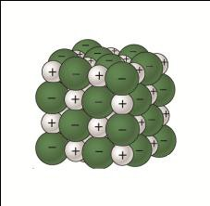
Sodium chloride (NaCl) is made up of sodium ions (Na⁺) and Chloride ions (Cl⁻). Use what you know about polar water molecules to explain why water is able to dissolve salt.
Since water is polar, it has an area of slight negative charge at one end of the molecule and slight positive charge at the other. The positive end of the water molecules attracts the negative chloride ions and the negative end of the water molecule attracts the positive sodium ions. Enough water molecules attracting the ions with enough energy can pull the ions apart and cause the salt to dissolve.

You saw that water is better than alcohol at dissolving salt (sodium chloride). Using what you know about water molecules, alcohol molecules, and the positive and negative ions in sodium chloride, explain why water is better than alcohol at dissolving salt.
Alcohol molecules only have one area that is polar and they have a large area which is not polar. These molecules cannot surround and attract the ions in salt as well as water molecules can. Therefore, alcohol does not dissolve salt as well as water does.

You placed an M&M in water and saw the sugar (sucrose) coating dissolve in the water. Use what you know about the polarity of water molecules and sucrose molecules to explain the process of water dissolving sucrose.
Water is polar because of the covalent bond between oxygen and hydrogen. There is a slight positive charge near the hydrogen and a slight negative charge near the oxygen. Sucrose also has a lot of covalent bonds between oxygen and hydrogen so it also has positive and negative areas. The polar water molecules attract the oppositely charged area of the sucrose and pull one sucrose molecule away from another causing the sucrose to dissolve.
When you put an M&M in oil, none of the sugar (sucrose) coating dissolved in the oil. Use what you know about the polarity of oil molecules and sucrose molecules to explain why oil does not dissolve the sucrose.
Oil is made of carbon atoms bonded to hydrogen atoms. These covalent bonds are not very polar. When an M&M is placed in oil, the oil molecules are not attracted to the sucrose molecules. The sucrose molecules are more attracted to each other than to the oil so the oil does not dissolve the sucrose.

You may have heard the phrase “oil and water don’t mix”. Using what you know about atoms, molecules, and dissolving, explain why you think this might be.
Oil is made up of carbon atoms bonded to hydrogen atoms. These C-H bonds are not very polar. When oil is mixed in water, the polar water molecules are more attracted to each other than to the oil so the oil and water do not mix.

How many variables is it necessary to control in order to conduct a fair test?
To conduct a fair test, you need to control all the variables except the one you are trying to learn about.

Is it better to compare mass or volume if you want to measure equal amounts of two different solid substances?
If you are trying to measure an equal amount of each substance, it is better to measure the mass of the two substances. If the pieces of the two substances are different size and shape, they will fill a scoop or spoon or other volume measure differently and you will have different amounts.

Solubility is a characteristic property of a substance. This means that the amount of a substance that dissolves in water is unique for that particular substance. Use what you know about the process of dissolving to explain why a substance would have its own characteristic solubility.
Dissolving depends on the attractions and interaction between the liquid (solvent) and the substance being dissolved (solute). These attractions depend on the atoms and molecules that make up the solvent and the solute. Since each substance is made up of its own unique type, number, and arrangement of atoms and molecules, each substance should have its own unique solubility.

When you let the water evaporate from the solutions you made, the recrystallized substances all looked different. Explain on the molecular level why the substances look different from each other when they recrystallize.
Since each substance has its own unique type, number, and arrangement of atoms and molecules, each substance would have a unique way of coming together and forming a crystal after the water evaporates.
To see if temperature affects dissolving, you put the same color M&M in cold, room temperature, and hot water. Explain why it was important to use the same color M&M in each temperature.
It’s possible that different M&M colors dissolve at different rates. So you want to use the same color to see if temperature affects dissolving. If you used different colors, you wouldn’t know if it was the temperature or the color that might be causing your results.

When you placed an M&M into cold, room temperature, and hot water, you saw that more of the sugar coating dissolved in the hot water than in the room temperature or cold water.
Explain, on the molecular level, why you think the hot water caused more of the sugar coating to dissolve.
Water molecules are moving faster in hot water. Also, the sucrose molecules are vibrating faster. The fast-moving water molecules that attract the sucrose molecules can pull on them with more force, causing more molecules to break away from other sucrose molecules and dissolve.

Your teacher added liquid food coloring to water. The food coloring mixed and dissolved thoroughly in the water. Would you guess that food coloring molecules are polar or non-polar? Explain.
I think they are probably polar. Since they mix so well with the water, maybe they have polar areas that the water molecules are attracted to that helps them mix thoroughly together.

You mixed alcohol, oil, and corn syrup into water to see which of these liquids dissolve in water. The alcohol and corn syrup dissolved in the water but the oil did not. Explain, on the molecular level, why the oil did not dissolve in the water.
Oil is made up of carbon atoms bonded to hydrogen atoms. These C-H bonds are not very polar. When oil is mixed in water, the polar water molecules are more attracted to each other than to the oil so the oil and water do not mix.

Here are pictures of a molecule of carbon dioxide (CO₂) and carbon dioxide dissolved in water. The carbon dioxide molecule has a slight negative charge near the oxygen atoms and a slight positive charge near the carbon atom. Using what you know about water molecules, and information from the drawings, explain why carbon dioxide molecules dissolve in water.
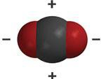
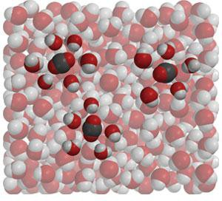

Since carbon dioxide has areas of slight positive and negative charge, and water has areas of slight positive and negative charge, they are attracted to each other. They are attracted enough so that carbon dioxide gas will dissolve in water.
How can you predict which solids, liquids, and gases dissolve in water?
Some substances like salt which are made of ions can dissolve in water. Polar substances like sucrose can dissolve in water. Liquids that are polar can dissolve in water. Gases like carbon dioxide which have polar areas can dissolve in water. You could predict that substances that are polar or have ionic bonds will probably dissolve in water.

The graph shows that as the temperature of water increases, the amount of carbon dioxide that can stay dissolved in the water decreases. Try to explain, on the molecular level, why less carbon dioxide dissolves in hotter water.
Carbon dioxide solubility in water
0.35
0.3
0.25
0.2
0.15
0.1
0.05
0
0
10
20
30
40
50
60
Temperature (C)
Solubility (g/100 g water)

The molecules in hot water are moving faster. If carbon dioxide molecules are dissolved in the water, they are also moving faster. Maybe this extra motion overcomes the attraction between the water and carbon dioxide and the carbon dioxide molecules break away and enter the air as a gas.
In terms of making and breaking bonds, explain why the temperature sometimes changes when solids are dissolved in liquids.
When water bonds to the solute, energy is released. But it takes energy to break the bonds of the solute and pull it apart. So if more energy is released in the bonding than it takes to break the bonds, the temperature goes up (exothermic). But if it takes more energy to break the bonds of the solute than is released when water bonds to it, the temperature goes down (endothermic).

Look at the pictures and explanations to help you answer the two questions, A and B below.
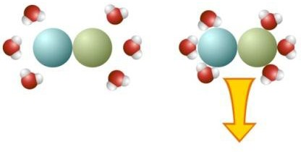

Water molecules attaching to a substance releases energy, causing the temperature to go up.
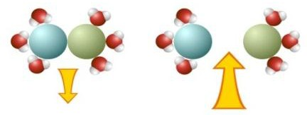

Water molecules pulling a substance apart absorbs energy, causing the temperature to go down.

The combination of energy released and energy absorbed determines whether dissolving a certain substance is endothermic (temperature decrease) or exothermic (temperature increase).

- Dissolving calcium chloride in water causes the temperature of the solution to increase (exothermic).
Look at the illustration and explain how the size and direction of the arrows indicates that dissolving calcium chloride is exothermic.

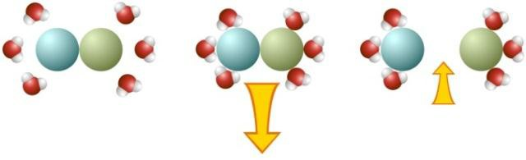

The energy being released when water molecules bond to the solute is greater (larger arrow coming out) than the energy required to pull the solute apart (smaller arrow going in). Therefore, this dissolving process is exothermic.

- Dissolving potassium chloride causes the temperature of the solution to decrease (endothermic).
Look at the illustration and explain how the size and direction of the arrows indicates that dissolving potassium chloride is endothermic.

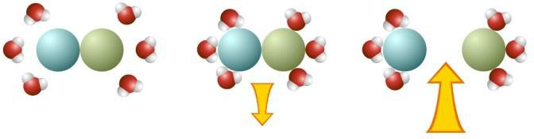

The energy being released when water molecules bond to the solute is less (smaller arrow coming out) than the energy required to pull the solute apart (larger arrow going in). Therefore, this dissolving process is endothermic.

